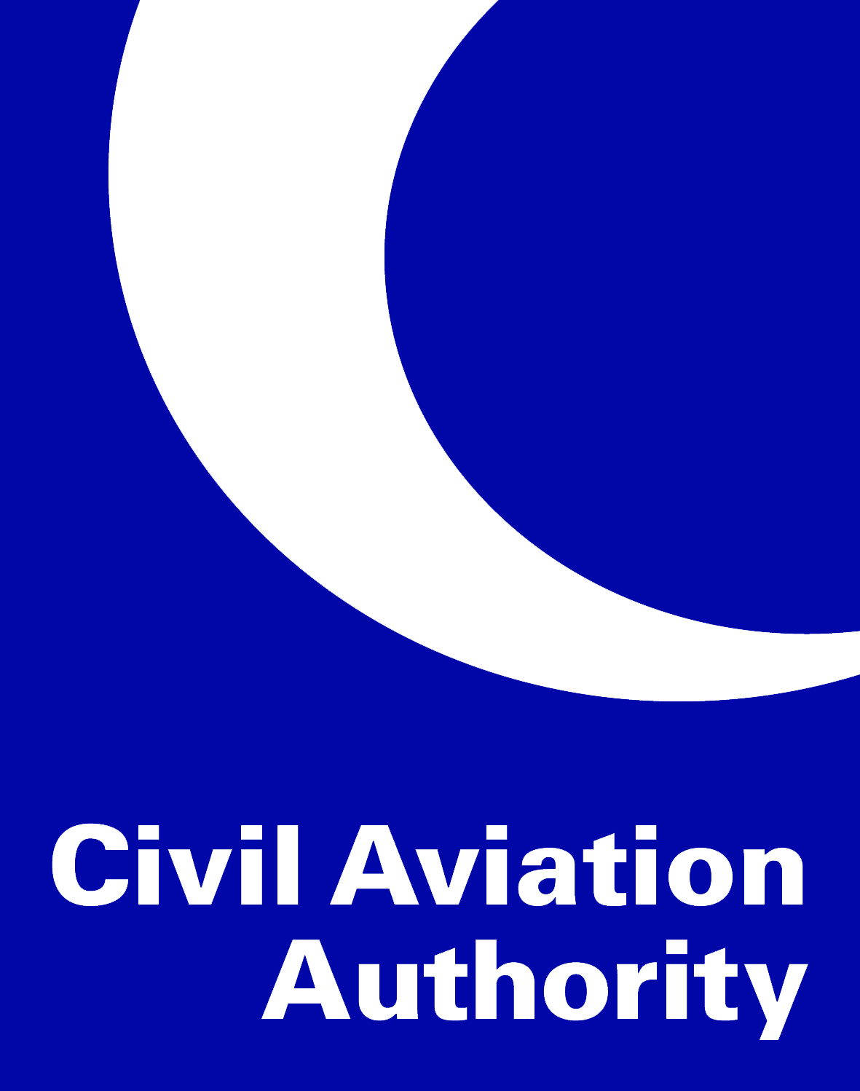

Deviation Acceptance and Action Document
No. | Date | Relevant Certification Specification (CS) | Description of non-compliance | Reference to supporting documentation | Review date
Aerodrome Operator Declaration
I hereby confirm that the details provided within this Deviation and Action Document (DAAD) are correct:
Signed: Print:
For and on behalf of:
(Name of Aerodrome and Aerodrome Operator)
FALSE REPRESENTATION STATEMENT
It is an offence under Article 256 of the Air Navigation Order 2016, as amended to make, with intent to deceive, any false representation for the purpose of procuring the grant, issue, renewal or variation of any certificate, licence, approval, permission or other document. This offence is punishable on summary conviction by a fine up to £5000, and on conviction on indictment with an unlimited fine or up to two years imprisonment or both.

CAA use only
Documentation received:
Reviewed by: Print:
Approved by: Print:
Date:

