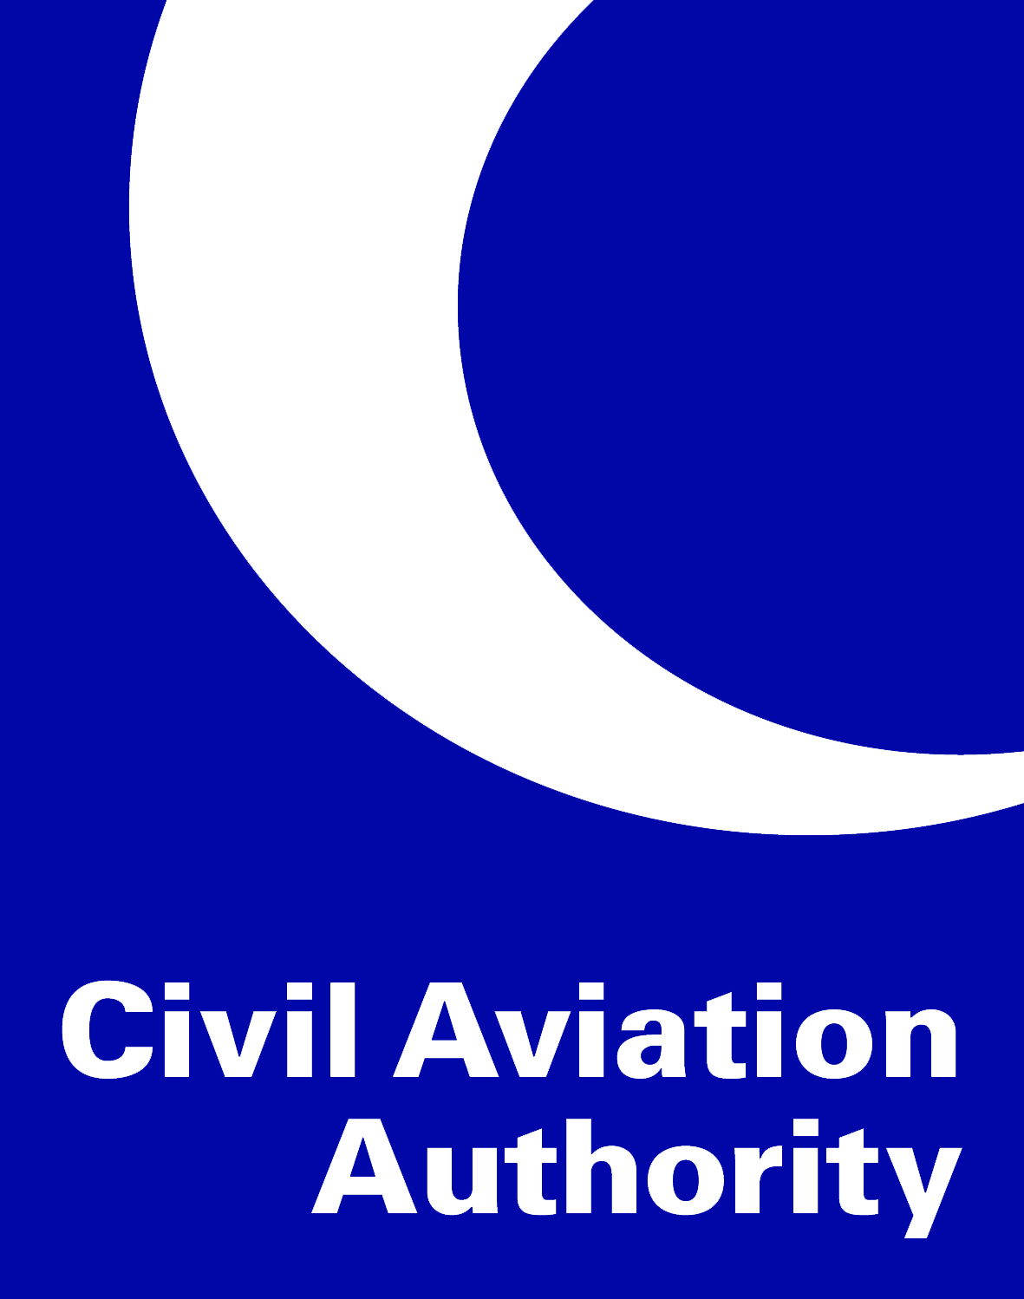

**EASA Aerodromes Transition**

**Instructions for the completion of the**

**Operations Basis (OB)**

**Introduction**

Upon receipt of the Operations Basis (OB) form from the CAA, the Aerodrome Operator (AO) should complete the document in the manner described below. In completing the OB, you are describing the management, operations and safety processes and procedures you have in place at your aerodrome that allows you to support the management, including safety management, and operation of the aerodrome. Secondly, you are demonstrating where you are meeting the relevant Acceptable Means of Compliance (AMC) and where not, are providing evidence of mitigation measures that may include the proposing of Alternative Means of Compliance (AltMoC).

The OB will support, and reference to, the material contained in the Aerodrome Manual.

Completion of the OB is undertaken in 2 phases.

**Phase 1**

The completion of this section only requires the reader to understand the scope of the rules. They do not need further work other than reading the rules and understanding their intent.



**Phase 2**

Phase 2 is completed by filling in the individual sections of the OB describing whether you have used the published EASA AMC or are proposing to use an AltMoC to meet the intent of the Implementing Rule (IR). The supporting material for all the questions should be included in the Aerodrome Manual. Therefore, reference to that location is also included in the OB.



A free text box is added below each rule for additional information you may wish to include in your answer. An example of which may be to propose an alternative means of compliance to the one published.

The completion of this phase finalises the building of the OB and once the document is signed by the Accountable Manager, becomes the legally binding record of the management, including safety management, and operation of the aerodrome.

As described in the rules, the OB must be reviewed when:

* + operations change (e.g. new a/c)
  + the Agency’s regulation changes  (i.e. possibly containing new obligation)
  + incidents or accidents occur
  + when change are needed that are subject to the general change management principles of ADR.OR.B.040